1. Go to: <https://www.npmjs.com>
2. Look for bootstrap, and try to understand does the website provids
3. Search for any utilities related to Instagram
4. Look for: @uppy/core
5. Check their popularity, quality, maintenance score
6. Click: @uppy/core
7. Explore the interface
8. Guidelines for developers to publish their packages ?: <https://docs.npmjs.com/files/package.json>
9. Download and then setup NPM on your machine: <https://nodejs.org/en/download>
10. Go to Mac terminal (On windows, search for the Windows Command Line). This lab will be based on Mac
11. To run programs with the security privileges of the superuser Type: >sudo –I, then Enter
12. To continue complete step 9 and install NPM, type: >npm install npm –g, then Enter
13. Check the versions: >node –v, then Enter and >npm –v, then Enter
14. Try to install a random package from NPM website (for example @uppy/core) by typing: >install @uppy/companion, then Enter
15. Now let’s try to create our own package. But first, what is Package.json file?

It is an important file which will have full details (e.g. name, version, author, and dependencies). It specifies also if the versions should be updated

1. To create your own package on your desktp, do these steps:
2. Create new folder on your desktop and name it mynpm.
3. Type >sudo –I, then Enter to login to the superuser
4. To check in which directory (i.e. folder) you are in now, type >ls, the Enter. This will list all folders and files in the current directory.
5. To exit from the current folder type >cd .., then Enter. To enter a specific folder type  
   >cd *FolderName*, then Enter
6. Keep doing that until you are on the right directory which is the desktop in our example
7. Now to enter inside the folder we created in step 17. Now type: >cd mynpm, then Enter
8. Now you are inside the directory where you want to create your package which you plan to publish and make others use it.
9. To run the wizard which will help you to create the package, type >npm init, then Enter.
10. Keep answering the questions on the terminal until you reach to an important step which is the main page of your package which is called the Entry point. Entry point is the main JavaScript file which will run when somebody use your package.
11. Before we tell the wizard about the name of our Entry point JavaScript file, lets try to create that file using any editor. In our case, we will use Adobe Brackets. So, open a new file in Brackets.
12. Let’s imagine our package do simple function which is printing the word Hello World on the screen. To do that type in the new file this statement: console.log("Hellow world");
13. Now save this file inside our NPM folder which was mynp and make the file name index.js.
14. Let’s try our package and type >node index.js, then Enter
15. Now let’s try to use others’work in our library and add it as a dependency. To do that all you need is to Install a package and save it as a dependency by typing: >npm install *packagename* –save, then Enter
16. Re-open the Package.json file in Brackets and check if the package hass been added to you library as a dependency
17. Now you have learned how install NPM, install packages, create you own package, and add dependency. All you need now is to figure out how to publish it to others. I know, it is a long journey. Try to learn it yourself ☺.

https://www.youtube.com/watch?v=jHDhaSSKmB0

1. Download the Node.js source code or a pre-built installer for your platform, and start developing today.

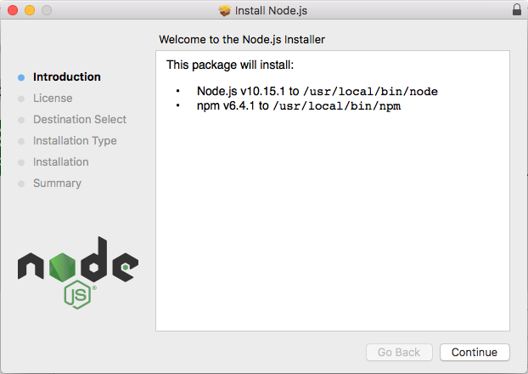

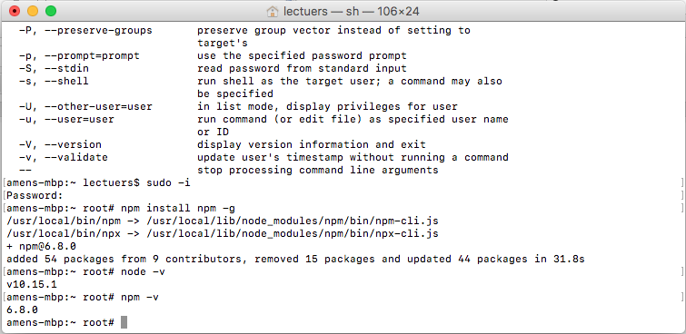

<https://uppy.io/docs/companion/#Installation>

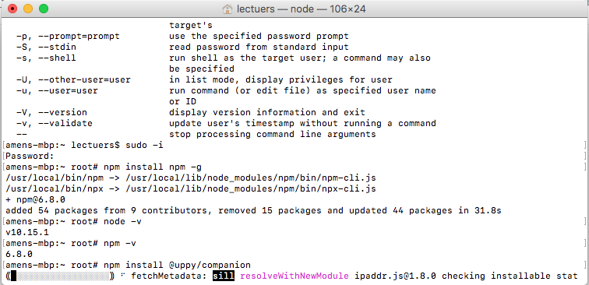

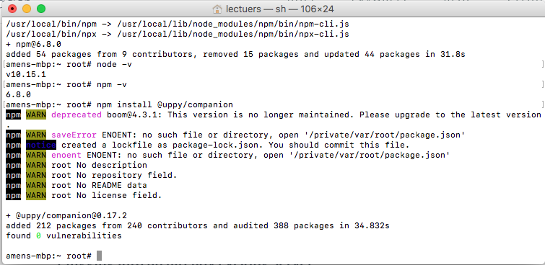

Ref: https://www.youtube.com/watch?v=jHDhaSSKmB0